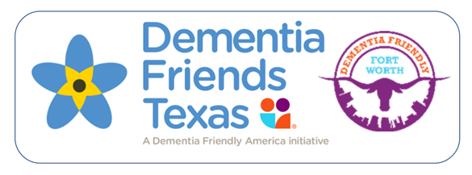
Session Reporting Form
Please complete this form after you have led a Dementia Friends Information Session. Log on as a Champion and input the information into the on-line reporting form on the Dementia Friends Texas page of Dementia Friendly Fort Worth. (DFFW.org) or mail to Dementia Friendly Fort Worth 750 w. 5th St. Fort Worth, TX 76102.

Date of Session: _____________________________________________________

Location: ___________________________________________________________
(Name of building, street address, city, state, zip code)

Start Time of Session: ________________________________________________

Name of Champion(s): _______________________________________________

Number of Dementia Friends made: ___________________________________

Which of the following describes the sector of individuals participating in the session? (check all that apply)

____ Business Sector  ____ Civic Organization  ____ Community Members (not  affiliated with a sector)  ____ Education  ____ Faith Community  ____ Government | ____ Library  ____ Medical/Health Care  ____ Senior Housing  ____ Social Service Organization  ____ Youth/Teens  ____ Other Describe:

Email Address of Dementia Champion: _________________________________

