HOW TO HAVE A DEMENTIA-FRIENDLY CHANUKAH
A traditional religious festival provides an opportunity for family and friends to celebrate together. Here we provide guidance to support those living with dementia at Chanukah, also known as Hanukkah.
Chanukah is a time for fun within Jewish communities. Family and friends gather together to celebrate this annual Feast of Dedication.
This eight-day thanksgiving is an important time within the Hebrew calendar. It carries with it many traditions enjoyed by all ages, including people with dementia. Here are some ways to provide support this Chanukah.
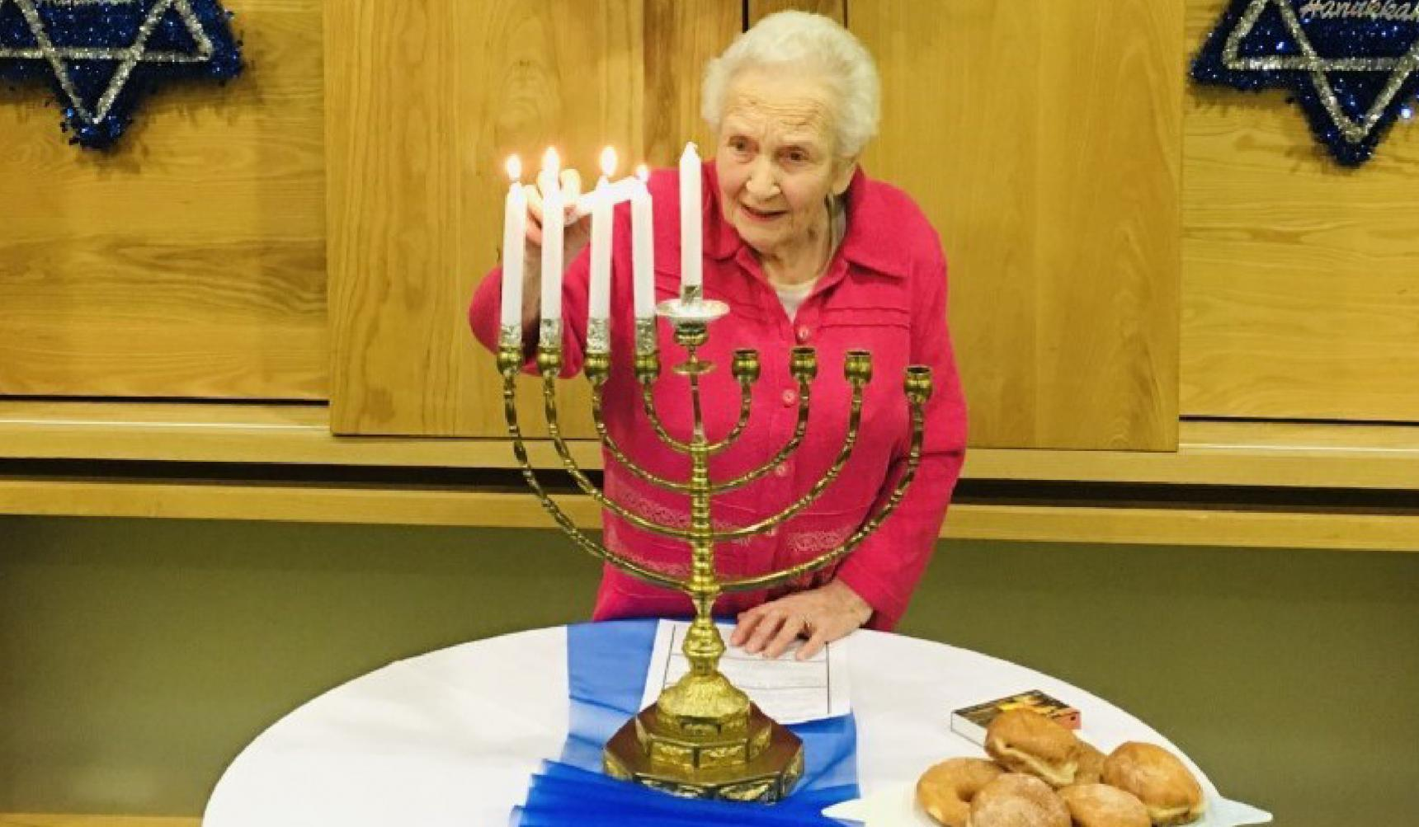
6 WAYS TO ENJOY A DEMENTIA-FRIENDLY CHANUKAH
1. Include traditional activities that could heighten the senses
Take part in activities such as lighting the Hanukkiah, spinning the dreidel, singing songs and eating Chanukah foods.
Smells, sounds and flavours may act as a ‘reminiscence tool' for someone with dementia, evoking memories from previous years.
2. Explore opportunities of enjoying a dementia-friendly service
Some Jewish community centres or synagogues might offer dementia-friendly services. These may be shorter than normal services, and could have more relaxed rules of conduct. It may also provide an opportunity for loved ones with dementia to hear older Chanukah songs that younger family members may not know.
In Jewish areas, public candle-lighting ceremonies often take place. This might be a nice activity to consider taking part in.
If a person is unable to travel to any events or services, it can be helpful to look at ways of celebrating in their own home instead. This may involve watching Chanukah celebrations on television or online, for example, and playing music for them that they will enjoy.
3. Be conscious of making changes to familiar environments
Vision and perception can sometimes be a problem for people with dementia. It may trigger anxiety if there’s a significant change to a familiar environment, particularly if there are lots of visitors.
Ahead of decorating, it may be beneficial to take out the menorah to talk about it. Make gradual changes to the space, such as furniture layout, to avoid confusion or stress.
4. Keep plans relaxed and allow for breaks
While having a planned structure can be helpful, it’s important to be flexible in the way you celebrate.
People with dementia may tire sooner or may wish to leave earlier than previous years. Be mindful of their changing levels of comfort.
Ensure a person with dementia has the opportunity to take a break from noise or conversations if they need a quiet space.
5. Encourage eating small amounts of traditional foods, rather than big meals
A person with dementia may feel overwhelmed when presented with a lot of food. Offer manageable servings of traditional treats. This could include potato latkes (crispy fried pancakes) or sufganiyot (small donuts).
If there are lots of distractions, a person with dementia may need gentle reminders to eat or drink.
6. Talk to family and friends about conversation tips
Avoid opportunities where someone with dementia is put on the spot to remember names. Particularly in big families, it may be challenging to remember family connections. If a mistake is made, try not to highlight it too much.
Speak with family members in advance about what they should say, especially younger children. It may help to avoid embarrassing moments for someone with dementia.
- Learn about dementia-friendly faith groups, and how faith can play a vital role in the lives and wellbeing of people living with and affected by dementia

Chanukah Sameach! (Happy Chanukah!)

